Tab 1

Software Engineering

Carrot Quest

Analysis Report

Developers: Ariana Brown , James McGuigan , Steven Foster, Adan Solano ,Jugraj Samra

Contents

Analysis Document 1 1
Introduction 4
Overview 6
Functional and Non-Functional Requirements 6
Functional Requirements 6
Start Screen 7
Game Canvas 8
Gameplay Mechanics 8
Obstacles 10
Scoring System 10
Game States 10
User Interactions 11
Gameplay Controls 11
Non-Functional Requirements 12
Visual Feedback 13
System Models 15
Use Case Models 16
Sequence & Dynamic Models 21
Objects & Class Models 25
User Interface (UI) 29
Conclusion 31
Contributions 32
Glossary & References 33

1. Introduction

1.1 General information about Carrot Quest
Our team has decided to program a game called Carrot Quest. Carrot Quest is a fun endless 2D vertical scroller game aimed to ignite our players' competitiveness. Users will play as a rabbit and leap across floating platforms with the objective of collecting as many carrots as possible. As the rabbit leaps higher into the sky, the challenge intensifies with fewer platforms appearing and obstacles obstructing its path. Failure to land on a platform or hitting an obstacle will result in a “GAME OVER” screen.

Carrot Quest aims to be an intuitive game, so anyone can play it with ease. We prioritize functionality, so our players can have an enjoyable experience playing our game. Carrot Quest is easy to learn for any newcomers playing the game , but also has some challenges to help keep the game exciting. Some features that we have included but not limited to:

- Single Player Game
- Smooth Graphics
- Random Generated Floating Platforms
- Obstacles
- Score System
- Scoreboard
- Game over screen

1.1.2 Score System
As mentioned before, we aim to interest our users with implementing a competitive aspect to our game. Studies have shown that competitiveness can increase game engagement. When players compete against others or themselves, they are more motivated to improve and try to outperform others. So, our team decided to implement a score system. While playing the game, players can find their current score on the top-left corner. The score is a visual indicator to the users of how many points they have acquired. The top 8 scores will be put onto the leaderboard. The leaderboard’s purpose is to show players their progress compared to other attempts..

1.2 Why did we choose Carrot Quest
Our team decided to make a game like Carrot Quest because it allows us to showcase our understanding of coding. We knew going into developing this game that we will face many unknown variables.To address this, we chose this concept to minimize as many unknown variables as possible.Creating a game like this is advantageous to the developer and the end user. Our team and the end user has a common interest of Carrot Quest being a functional game.To achieve this, we engaged in detailed discussions about our vision for the game and the implementation strategies needed to minimize unforeseen errors.Our aim is to deliver a seamless gaming experience that ensures players have an enjoyable experience.

2. Overview
2.1 Character
In Carrot Quest, players will play as a Rabbit named Charlie. Players will guide Charlie towards floating platforms to help get carrots to make a carrot cake.

2.2 Objective
Welcome to Carrot Quest. Players will be transported into the world of Carrot Quest with the sole purpose of helping our furry friend collect carrots. Players will hop on platforms to collect as many carrots as possible. Collect carrots to increase your score counter. Don’t be fooled by the colorful scenery, as you climb higher into the sky bombs will appear and less platforms will spawn. Protect your furry friend by avoiding the bombs by safely maneuvering to the next platform. Players will have to actively use their problem-solving skills to ascend higher into the sky.

2.3 Gameplay
Players are controlling the bunny. The controls are:
- ‘A’ - move to the left
- ‘D’- move to the right

Rabbit will auto jump. Players should try to land on the closest platform above them. Landing on each platform will reward the player with a point. There will be no time limit in the game. Player will play indefinitely until they meet one of the two conditions:
- Fall off the platform
- hit an obstacle

2.4 Avoiding Obstacles
Players will have to avoid bombs, which will appear randomly in the game. Players must avoid touching the bomb. If the rabbit collides with the bomb, they will instantly die resulting in a game over. As the rabbit gets higher in the air there will be less platforms spawning. Which adds another challenge to the player.
2.5 Scenery
There will be 3 different sceneries in our game. There will be a background for the main menu, game screen, and end game screen. Transition between backgrounds will be seamless. All backgrounds will be visually appealing to the players and clearly show the games environment. Backgrounds will also not be too distracting, so the players can easily see the rabbit.
2.6 Score
On the top left corner there is a score system. When the bunny collects a carrot they gain points. When the game is over, your score will be saved into the database. All data will be saved into the database. If your score is apart of the top 8 you will enter a name of 3 characters. The leaderboard will show the top 8 scores and their 3 character name.

2.7 Sound
Sound will be playing in the background.

Functional and Non-Functional Requirements

3. Functional Requirements
3.1 User Interface (UI)
"Carrot Quest" is designed to have a user-friendly interface that enhances the player's gaming experience. The playful aesthetic, coupled with intuitive navigation, ensures that players can easily interact with the game’s features.
3.1.2 Text and Style
· The game's font is written in 'Bubblegum Sans' to create a fun and inviting atmosphere for the player.
· Bright, engaging color schemes are used to keep the game visually appealing, with shades of deep pink, white, and light pink forming the core design palette.

Start Screen
3.2 Main Menu Screen
· A visually appealing field themed background (Menu_Screen.png) sets the tone for the game from the start.
3.2.1 Interactive Elements
· The main menu contains three buttons: "Play," "Instructions," and "High Scores."
· The game title features a lively bouncing animation, further immersing players in the playful design.
3.2.3 Instructions Screen
· Players can access the instructions screen via the "Instructions" button on the main menu.
· The background image (instruction_background.png) is designed to fit the playful yet informative tone of the game.
· Instructions are concise, providing players with all necessary gameplay mechanics in an easy-to-understand format.
3.2.4 High Scores Screen
· This screen is accessible from the main menu and displays a list of the top scores achieved by players.
· The background (High_Score_Background.png) complements the rest of the game's visual identity, ensuring continuity across different screens.

Game Canvas
3.3 Primary Gameplay Area
· The game canvas is designed to be dynamic, fully utilizing the browser window's width and height to create an immersive experience for players while facilitating compact, streamlined gameplay.
· A themed background (CarrotQuestBackground.mp4) enhances the overall atmosphere of the game allowing for visual aesthetic and supports the game's progression.
3.3.1 Game Over Screen
· This screen appears when the game ends due to either a collision with an obstacle or falling off the screen.
· The background (GameOver_Screen.png) is consistent with the game's overall visual theme.
· The player’s final score is displayed prominently, with buttons for restarting the game or returning to the main menu.

Gameplay Mechanics
3.5 Rabbit Character
· Players control a charming rabbit character, the main protagonist of the game.
· The rabbit has two distinct visual states: facing right (rabbit-right.png) and facing left (rabbit-left.png).
· The character is set to a fixed size of 100x100 pixels, ensuring consistent interaction with the game world.
3.5.1 Movement and Physics
· Players move the rabbit horizontally using the arrow keys or 'A' and 'D' keys.
· The game incorporates realistic physics, with gravity and jumping mechanics affecting the vertical movement of the rabbit.
· The rabbit can wrap around the screen horizontally, adding an additional layer of strategic gameplay.
3.5.2 Platforms
· Platforms are randomly generated and move downwards as the rabbit ascends higher.
· This kind of dynamic generation for the platforms appearing improves the quality of gameplay by adding additional motion.
· Each platform is sized at 450x250 pixels and uses the platform.png image to maintain consistency with the overall design.

Obstacles
3.6 Bombs
· Bombs serve as obstacles scattered throughout the game.
· If the rabbit collides with a bomb, the game immediately ends, emphasizing the need for careful navigation.

Scoring System
3.7 Real-Time Score Calculation
· Players earn points as they ascend higher in the game, with the score being updated in real-time.
· The scoring mechanism is based on the height reached by the player, encouraging continued progression.

Game States
3.8 Menu State
· Initial State
· The game begins in the menu state, allowing players to navigate between the main menu, instructions, and high scores screens.

3.8.1 Playing State
· Active Gameplay
· This state is activated once the player starts the game. The game runs in a continuous loop, updating game elements like character movement, platform generation, and obstacle appearance.
3.8.2 Game Over State
· End of Game
· Triggered when the rabbit collides with a bomb or falls off the screen, this state displays the final score and options for restarting or returning to the main menu.

User Interactions
3.9 Menu Navigation
· Simple Navigation for ease of use to a new player.
· Players can navigate between screens (main menu, instructions, high scores) by clicking the appropriate buttons.

Gameplay Controls
3.10 Keyboard Inputs
· During gameplay, players use the keyboard to control the rabbit’s movement.
· The game actively listens for key down and key up events to provide responsive gameplay.

3.10.1 Restart and Return to Menu
· These are options provided below the score on the game over screen
· After a game is over, players are presented with options to either restart the game or return to the main menu, allowing for seamless gameplay.

4. Non-Functional Requirements
4.1 Performance
· Frame Rate and Smoothness
· Animation Handling
· The game uses the requestAnimationFrame method for smooth animations and optimal performance, ensuring that gameplay remains fluid across devices.
4.1.2 Resource Management
· Image Preloading
· All necessary images are preloaded to avoid any in-game delays, ensuring that the player’s experience remains uninterrupted by technical glitches.
4.1.3 Scalability
· Dynamic Canvas Sizing
· Responsive Design
· The game canvas automatically adjusts to fit the full width and height of the browser window, making the game adaptable to different screen sizes and resolutions.
4.1.4 Adaptive Difficulty
· Progressive Challenge
· The game’s difficulty can be dynamically adjusted to gradually increase as the player progresses, ensuring a challenging experience for both beginners and seasoned players.
4.1.5 Usability
· Intuitive Controls
· Familiarity
· The game leverages standard arrow keys and WASD controls to make gameplay intuitive for players familiar with common platform games.

Visual Feedback
4.2 Directional Feedback
· The rabbit’s sprite changes direction based on player inputs, providing clear and immediate visual feedback during gameplay.

4.2.1 Accessibility
· Color Scheme
4.2.2 Visibility
· The game uses a high-contrast color scheme to ensure visibility for all players, including those with visual impairments.
4.2.3 Audio Cues
· Future Expansion
· Not currently implemented, the game’s design allows for the addition of audio cues and feedback, which could enhance the experience for players with hearing impairments.
4.2.4 Maintainability
· Modular Code Structure
· Code Organization
· The game’s JavaScript code is organized into modular functions, ensuring maintainability and ease of updates.
4.2.5 CSS Styling
· Separation of Concerns
· Visual elements are handled via a separate CSS file, allowing for streamlined design updates without affecting the core game logic.
4.2.6 Compatibility
· Cross-Browser Support
· Browser Agnostic
· The game is built using standard web technologies (HTML5, CSS3, and JavaScript), ensuring compatibility across all modern browsers.
4.2.7 Mobile and Desktop Support
· The game is designed to function seamlessly on both desktop and mobile platforms, with controls that can be adapted for touch-based input on mobile devices.
4.2.8 Security
· Input Sanitization
· Preventing Exploits
· Input sanitization is necessary, particularly for handling high score submissions to prevent malicious inputs or tampering with scores.
4.2.9 Localization
· Text Externalization
· Language Support
· The game’s text content can be externalized, allowing for easy localization into multiple languages, expanding its reach to global audiences.

System Models

5. Activity model

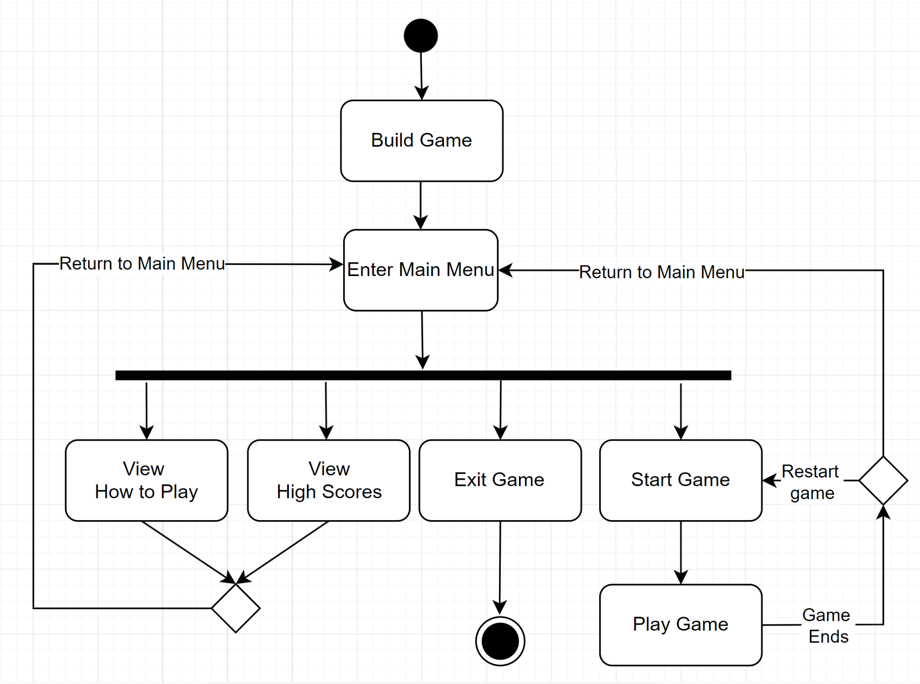

6. Use Case Model
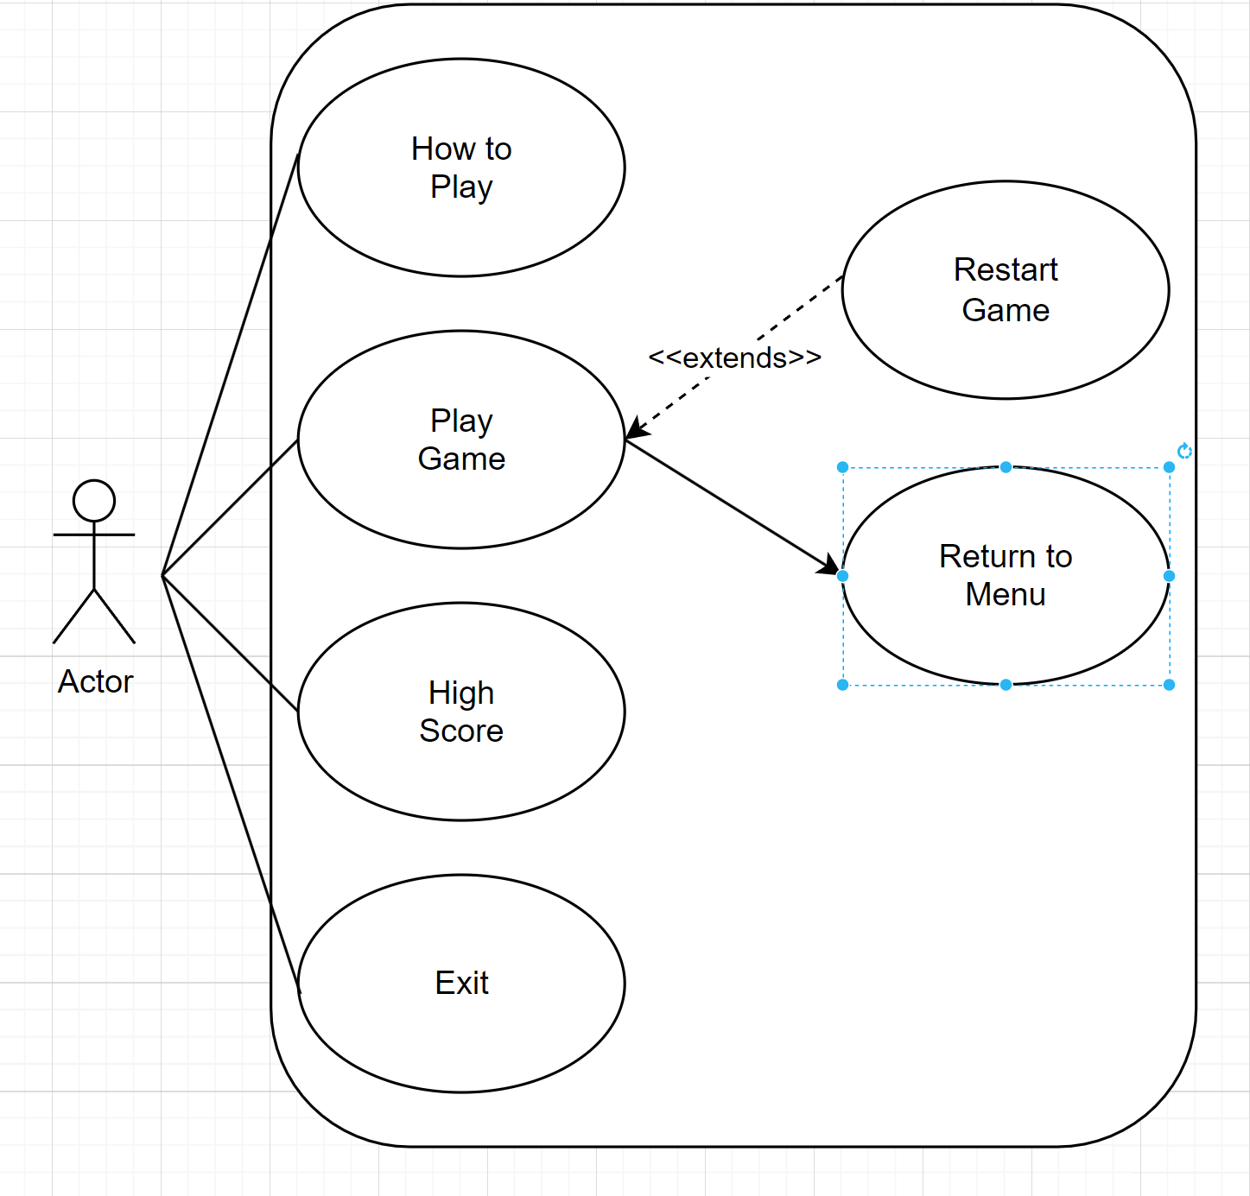

Use Case #1
________________________________________________________

Use Case: Play game w/ game over to menu and restart
Primary Actor: Player

Stakeholders and Interests:

Player selects ‘New Game’ from the main menu.

Pre-conditions:

Players must be in the main menu.

Post-conditions:

Game over screen has loaded

Entry-conditions:

Player selects the ‘New Game’ button from the main menu.

Exit conditions:

Player returns to the main menu.

Player starts another run.

Success Scenario Event Flow:

- Player selects the ‘New Game’ button from the main menu.

- System allows the player to complete the run and loads the game over screen.

Alternative Event Flows:

- Player has paused the game
  - Player views pause menu instructions
  - Player exits to main menu
  - Player resumes game

Use Case # 2
________________________________________________________

Use Case: Player Views Instructions
Primary Actor: Player

Stakeholders and Interests:

Player selects ‘Instructions’ from the main menu.

Pre-conditions:

Players must be in the main menu.

Post-conditions:

Instructions screen has loaded

Entry-conditions:

Player selects the ‘Instructions’ button from the main menu.

Exit conditions:

Player returns to the main menu.

Success Scenario Event Flow:

- Player selects the ‘Instructions’ button from the main menu.

- Instruction Screen Loads

Alternative Event Flows:

Use Case # 3
________________________________________________________

Use Case: Player Views High Scores
Primary Actor: Player

Stakeholders and Interests:

Player selects ‘High Scores’ from the main menu.

Pre-conditions:

Players must be in the main menu.

Post-conditions:

High Score screen has loaded

Entry-conditions:

Player selects the ‘High Score’ button from the main menu.

Exit conditions:

Player returns to the main menu.

Success Scenario Event Flow:

- Player selects the ‘High Score’ button from the main menu.

- System queries for top 10 high scores.

- System Displays top 10 high scores.

Alternative Event Flows:

Use Case # 4
________________________________________________________

Use Case: Player Exits Game
Primary Actor: Player

Stakeholders and Interests:

Player selects ‘Exit’ from the main menu.

Pre-conditions:

Players must be in the main menu.

Post-conditions:

Game window has closed

Entry-conditions:

Player selects the ‘Exit’ button from the main menu.

Exit conditions:

Game window or tab closes

Success Scenario Event Flow:

- Player selects the ‘Exit’ button from the main menu.

- System closes current game instance

Alternative Event Flows:

7. Sequence & Dynamic Models

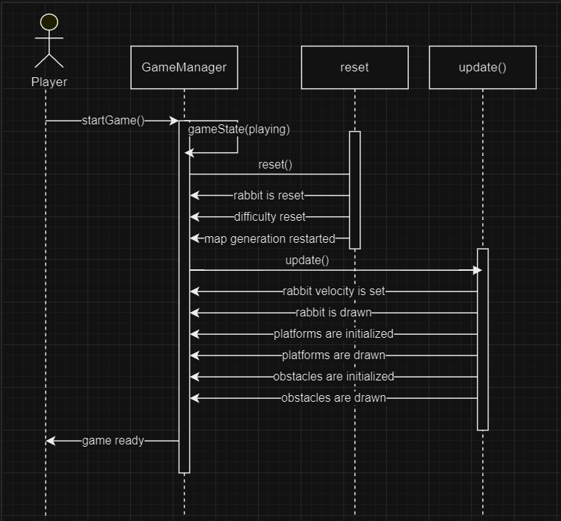
New Game

7.1 How to play
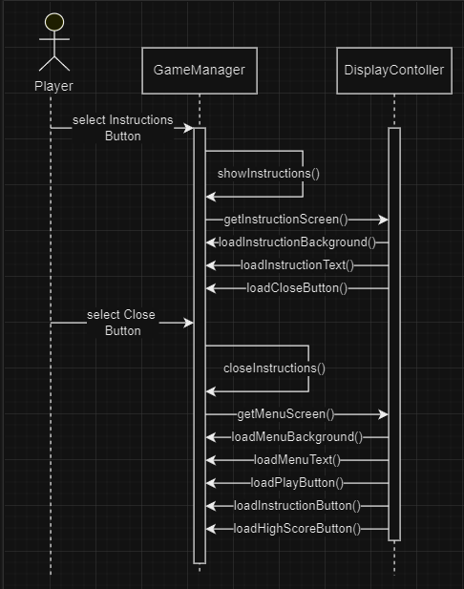

7.2 Pausing the Game

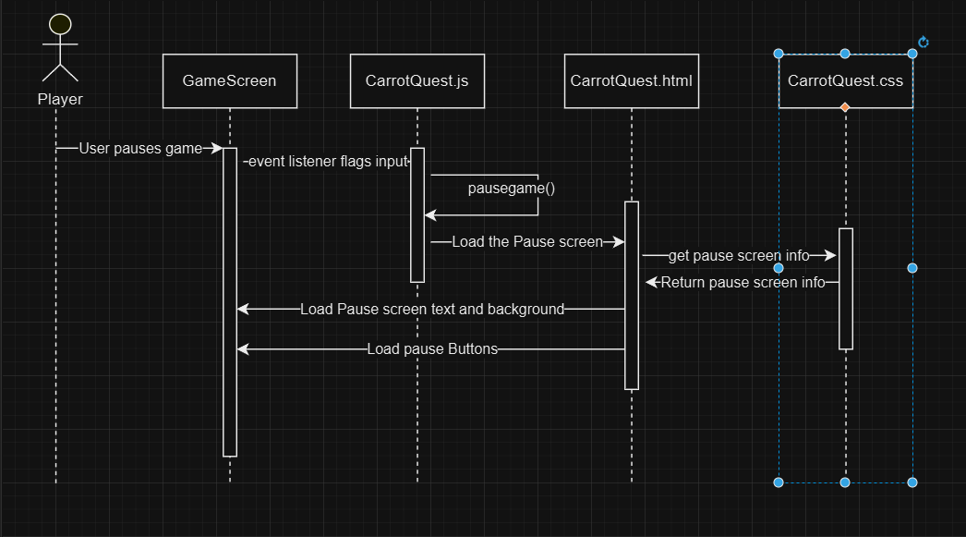

7.3 Launching game
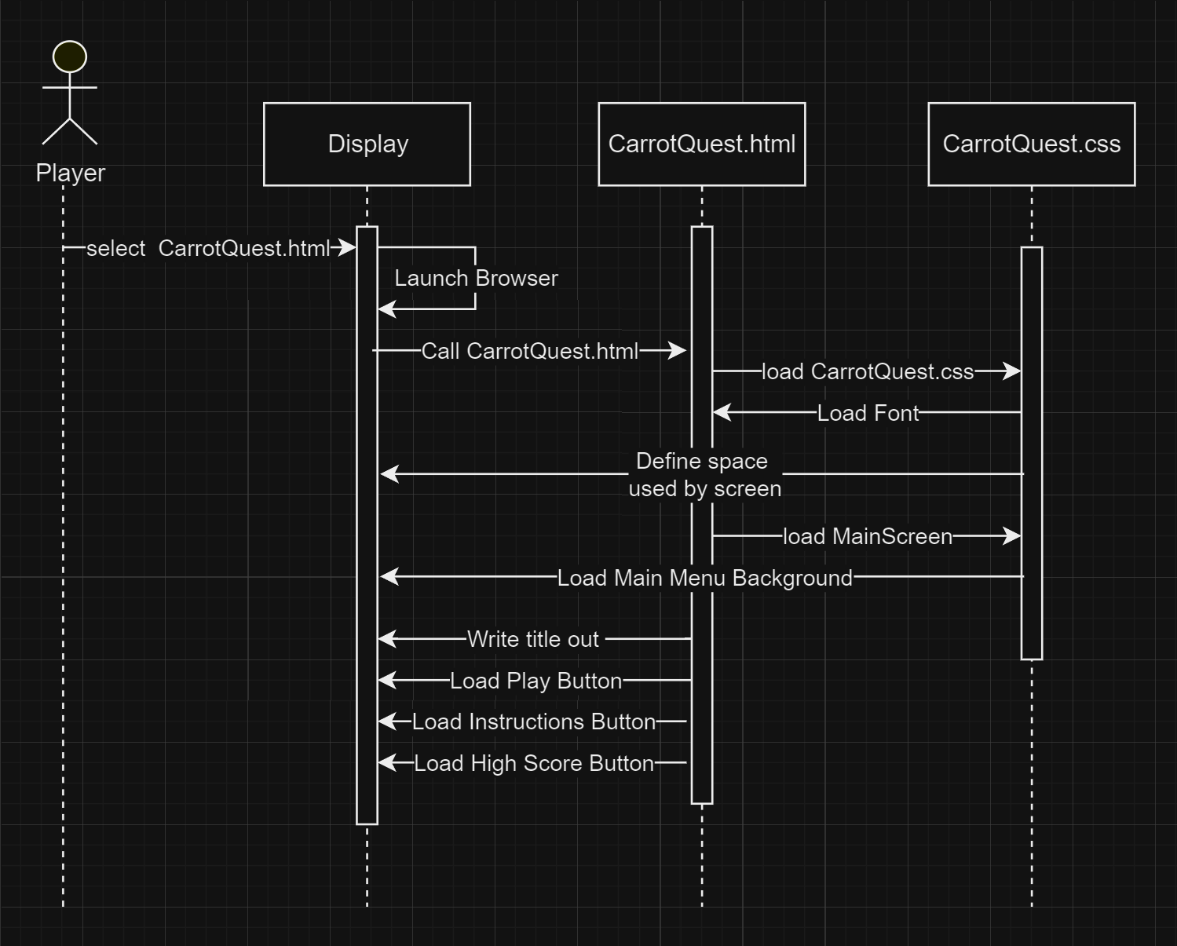

8. Objects & Class Models

8.1 Java Code
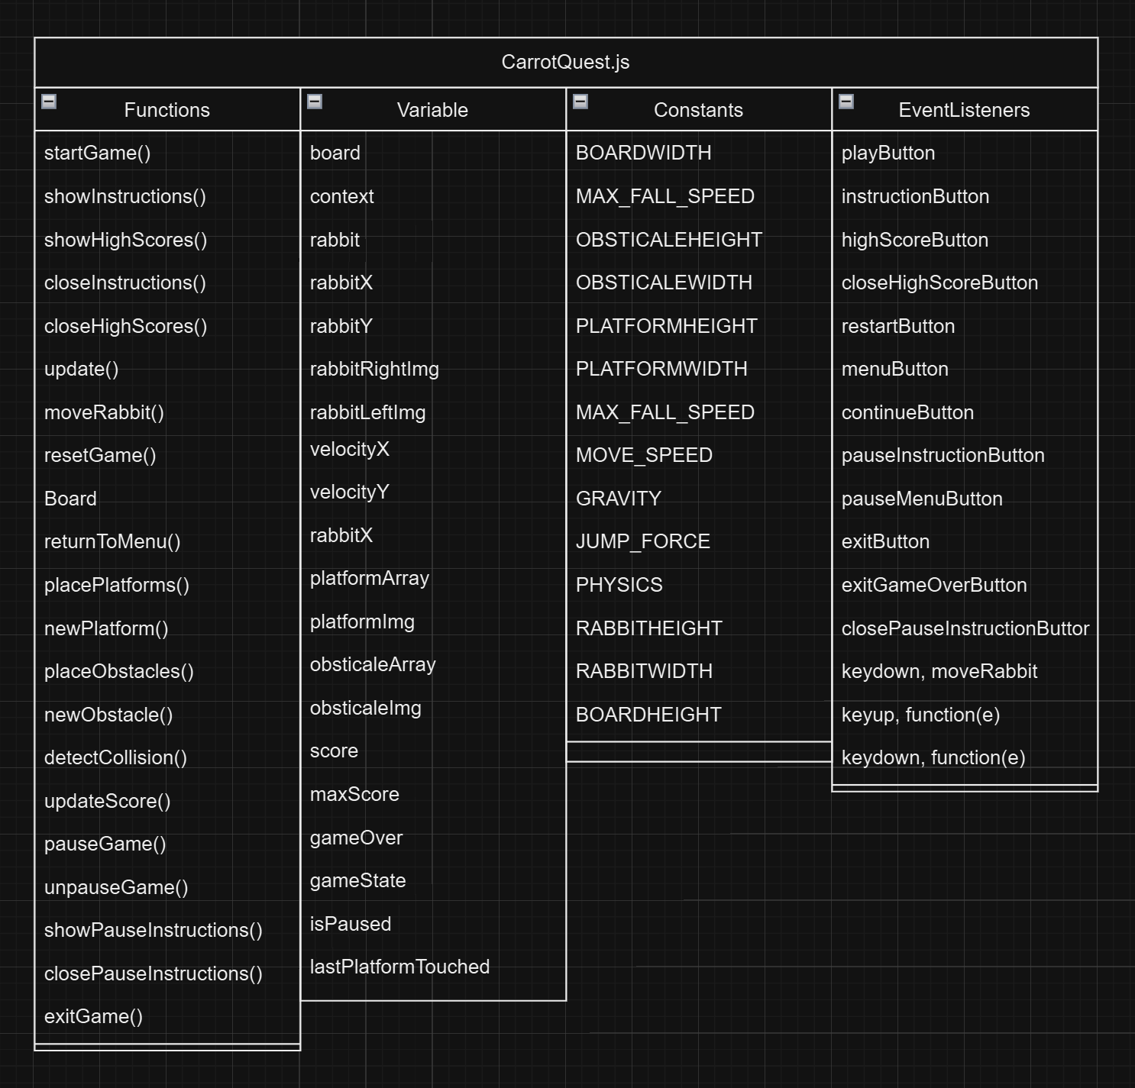

8.2 CSS Code
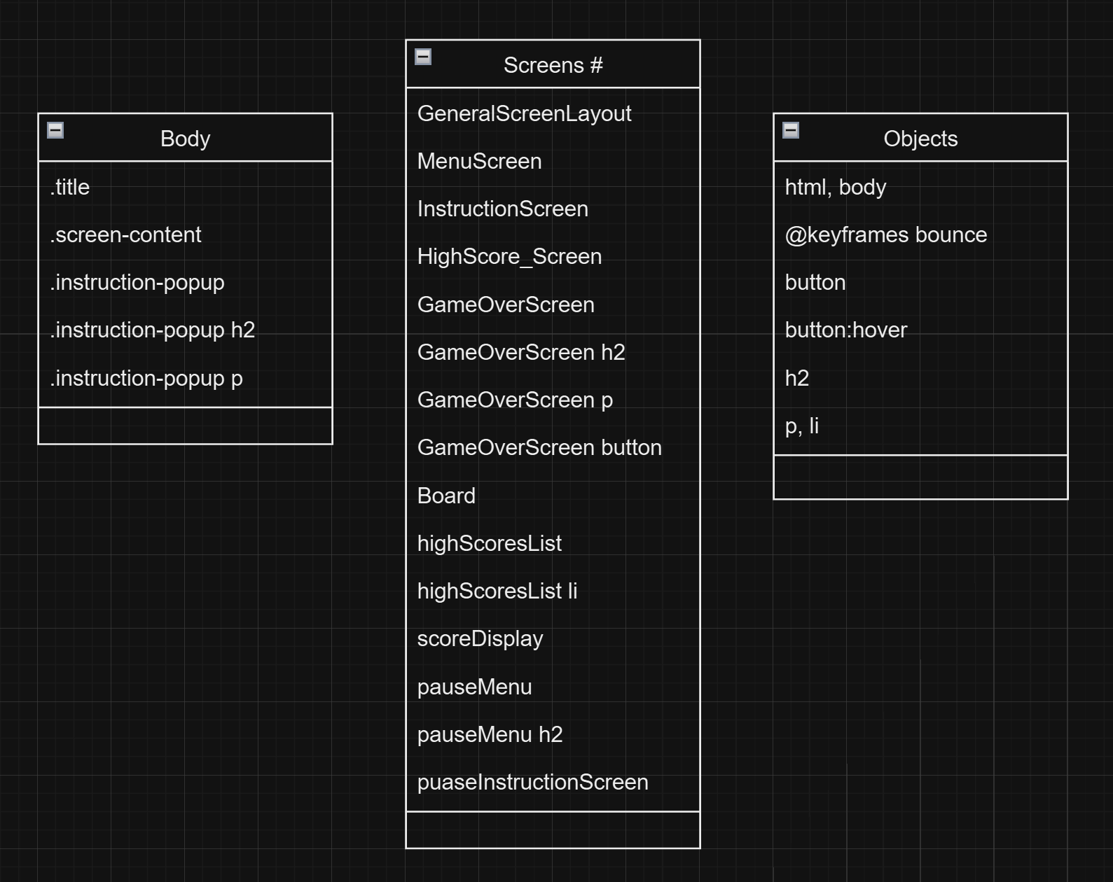

8.3 HTML Code
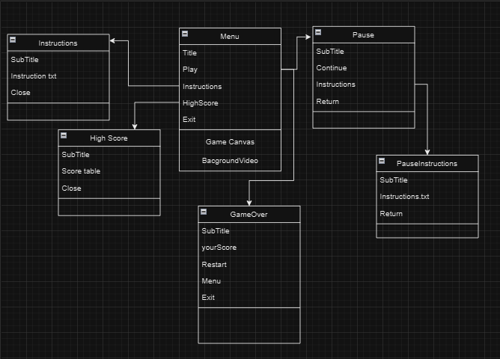

9. User Interface (UI)
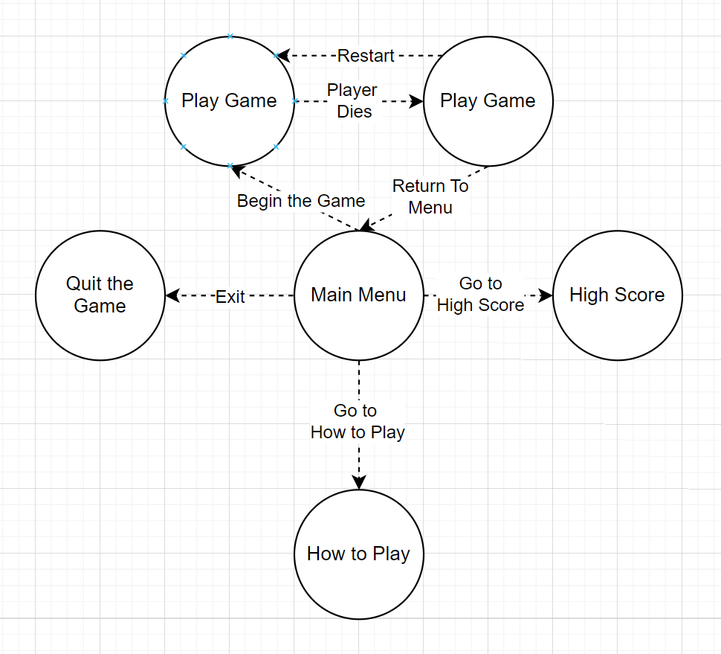

The user interface of “Carrot Quest” has four main branches off the main menu. The first and primary being the Play Game branch, which is loop-able until the user wishes to exit it. The second being the Instructions branch, which allows the user to view the game instructions and return to the main menu. The next being the High score branch which will show the user the high scores for the game and allow them to return to the main menu. The final is the Exit branch which closes the game.

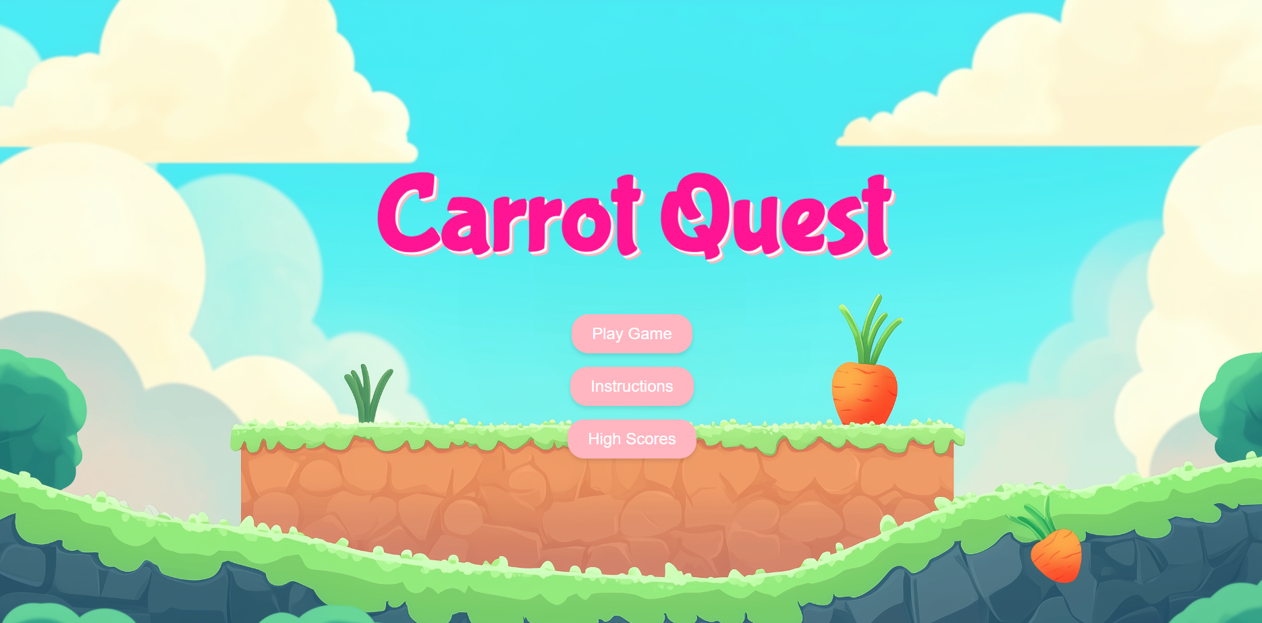
The main screen of our application features an engaging background that gives the users an immersive visual to the theme of our game. The background of the main screen fills the entire window with vibrant colors and aesthetic visuals, emphasizing the theme of the game. At its center, the title "Carrot Quest" is displayed in a Bubblegum Sans font, being the focal point of the interface. Each button is designed with transition effects, creating a subtle pop of the button on hover that enhances user interactivity. As users navigate, the buttons illuminate and subtly enlarge, encouraging further user exploration and interaction within the menus.The title includes a gentle floating effect, adding a dynamic look to the menu design. Below the title, thoughtful animations create a cohesive and engaging environment. The menu layout has dynamic visual structure, guiding users effortlessly into each part of the games main menu items within the interface.

10. Conclusion
Carrot Quest is a game designed to be simple yet enjoyable. The thought process being to make a game that shouldn’t require immense effort yet still makes the player want to replay it over and over and over again. Something akin to mobile games from when we were younger. At its core it’s a game not meant entirely for competitive play, though it could be used for such by beating each other’s high scores. It's made more for down time when someone is procrastinating their work or is just trying to kill time when nothing else is available. We wanted to go with a look that was welcoming, hence the bubblegum aesthetic of the overall game. In terms of who does what, we split it up according to our own individual strengths, which can be seen with the contributions section below. We also split up sections in this document to clearly specify who does what. We have also split up our share of contribution to this very document, just so that it is all fair and square. We put immense trust in each other when it came to everyone’s process and consulted with each other heavily in regards to how we went about the game's design from the U.I, to the movement of the player, to the background elements. We would dedicate time either before or after class to sit down and discuss how we would go about certain aspects of the game as well as checkup on each other's progress to make sure everything is going smoothly.
Additionally, even when we were confident on what the look and feel of the game would be like, we would still make changes that we thought were better than we came up with before. We didn't think they were bad, just that we found options that were better suited for how we wanted our game to look. We want to provide an experience that can please as many people as possible.

Contributions
- James M. (Project Leader, Introduction, Functional Requirements, Non-Functional Requirements, User Interface, contributions):
  - Responsible for overseeing the project, ensuring alignment with both functional and non-functional requirements. He will coordinate the development process, manage timelines, and facilitate communication among team members to maintain a cohesive workflow. James will also take the lead in integrating UI elements with HTML, CSS, and JavaScript.
    - Involvement during the Analysis:
      - Establishing the Introduction
      - Drafting Functional Requirements
      - Defining Non-Functional Requirements
      - Coding the Menu Screen
      - Enhancing User Interface Context
      - Contributing to the Glossary and Document Edits

- Ariana B. (Introduction, Overview, Editor):
  - Tasked with crafting the introductory sections of the document, Ariana will provide a comprehensive overview of the project’s goals and objectives. As the editor, Ariana will ensure clarity and coherence throughout the document, maintaining a consistent tone and structure that effectively communicates the project's purpose and scope.
    - Involvement during the Analysis:
      - Edited the Document along with Jugraj
      - Created the Introduction sections
      - Created Overview section
- Steven F. (Activity Diagram, Use Case Models, Dynamic/Sequence Models, Object and Class Models, User Interface):
  - Steven will focus on modeling the system through detailed activity diagrams and use case models, which will highlight user interactions and system functionality. Additionally, he will develop dynamic and sequence models to illustrate system processes and interactions over time, as well as object and class models that define the underlying architecture of the application. His contributions to the user interface design will ensure that it is both functional and user-friendly.
    - Involvement during the Analysis:
      - Created Activity Diagrams with Adan
      - Created Use Case Models with Adan
      - Refined User Interface

- Adan S. (Activity Diagram, Use Case Models, Dynamic/Sequence Models, Object and Class Models, User Interface):
  - Working alongside Steven, Adan will collaborate on creating activity diagrams and use case models to further detail user interactions. He will also contribute to dynamic and sequence modeling, providing insights into the system's behavior in response to various stimuli. Adan will assist in refining the user interface to enhance usability and engagement.
    - Involvement during the Analysis:
      - Created Activity Diagrams with Steven
      - Created Use Case Models with Steven
      - Refined User Interface
- Jugraj S. (Conclusion, Glossary and References, Contributions, Editor):
  - Jugraj will culminate the findings of the project in the conclusion, summarizing key insights and implications. He will also compile a glossary to define technical terms and concepts, making the document accessible to all readers. Additionally, he will document team contributions, highlighting each member's role and impact on the project. As an editor, Jugraj will ensure the final document is polished and professional.
    - Involvement during the Analysis:
      - Wrote the Conclusion
      - Edited the document along with Ariana
      - Contributed to the Glossary

Glossary & References
Sprite : a graphic object or animation that is integrated into a larger game or scene in computer graphics and coding
Localization : the process of making something local in character or restricting it to a particular place
Maintainability : the ease with which a software system can be modified, updated, or repaired

Stable Diffusion: a text-to-image model developed by Stability AI.
Reference:
Automatic1111 et al. (2022). Stable Diffusion Web UI. GitHub repository. Retrieved from https://github.com/AUTOMATIC1111/stable-diffusion-webui

https://app.diagrams.net

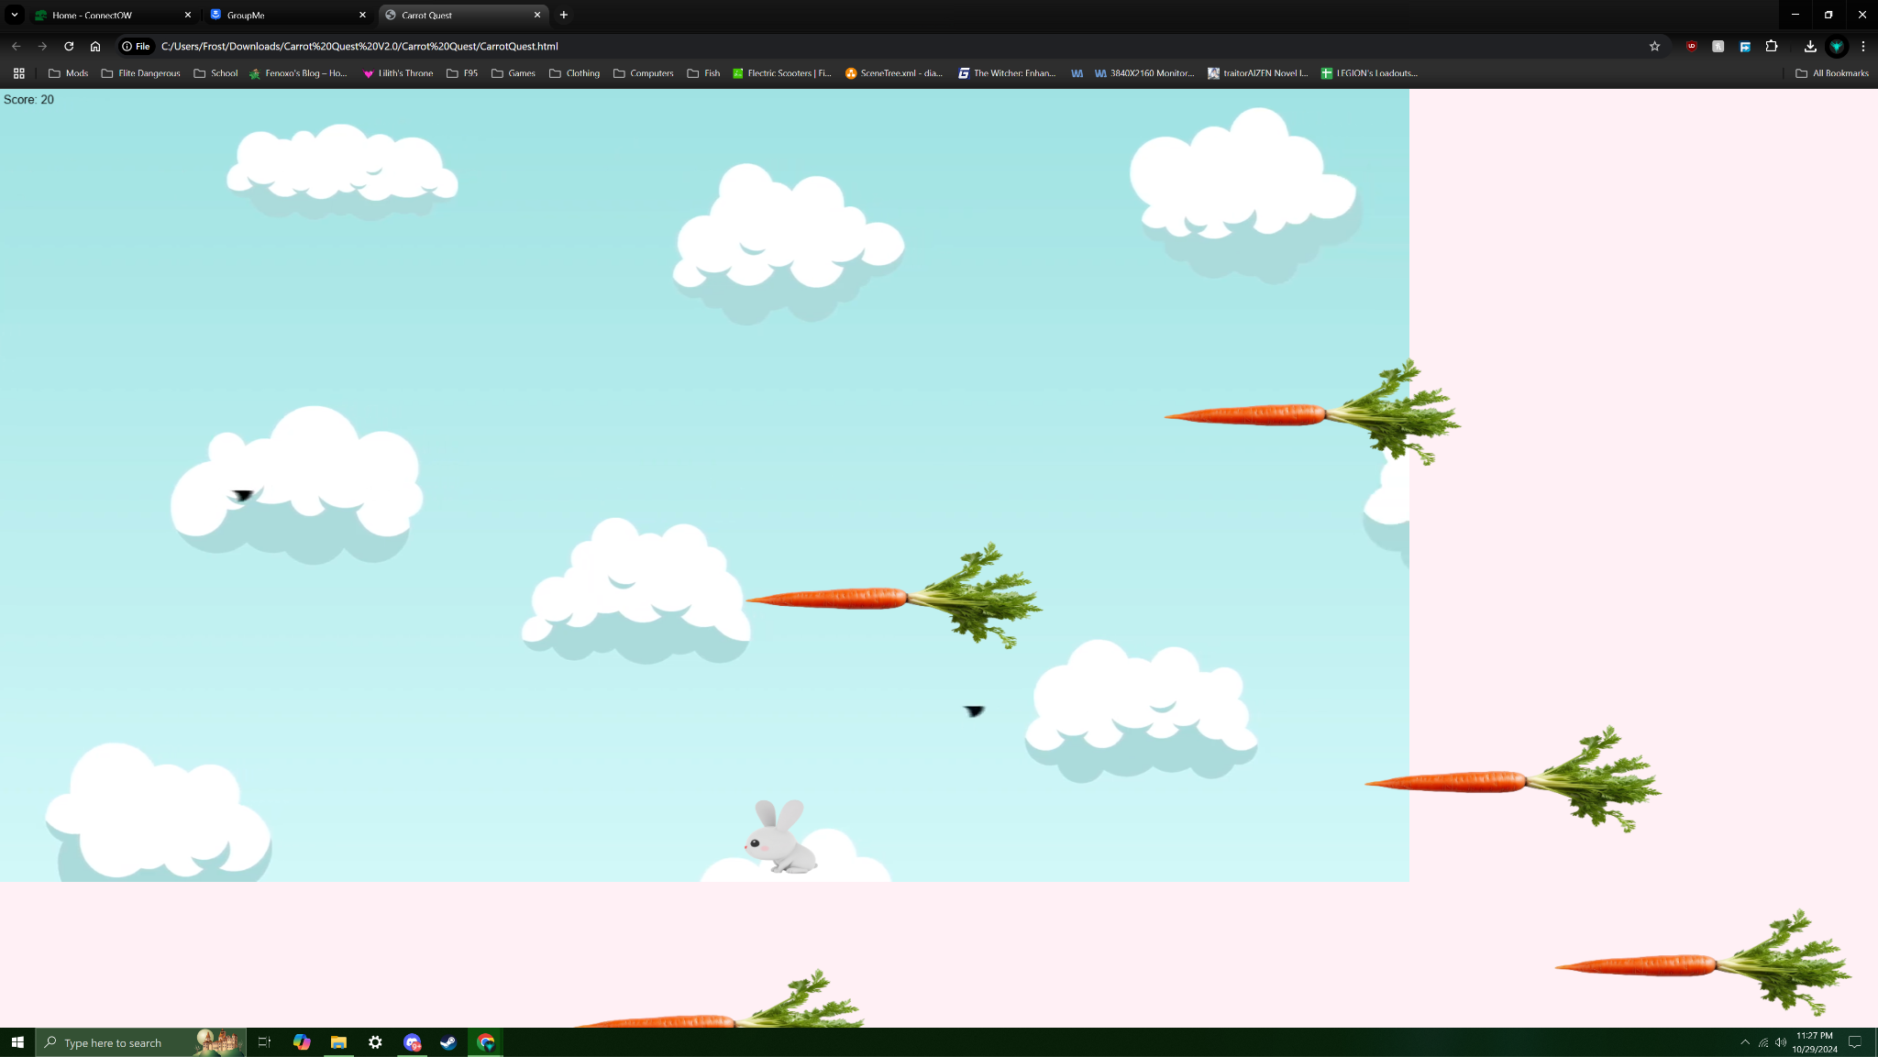

Lucidchart

